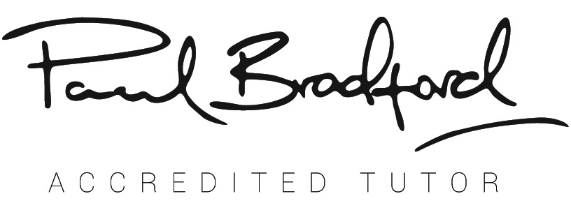

SUMMARY OF CONTENTS

|  |  |
| --- | --- |
| 1 | Course timetable |
| 2 | Summary of AT tutorials |
| 3 | Self-selection questionnaire |
| 4 | Terms and conditions of application |
| 5 | License Agreement |
| 6 | FAQs |
| 7 | Adding your courses guide |
| 8 | 30 Day Action plan |
| 9 | Business Plan template |
| 10 | Joining Instructions template |
| 11 | T&Cs template for your attendees |