Cakeflix Pro Business Bootcamp.
Week 4: 26.01.21
Branding.

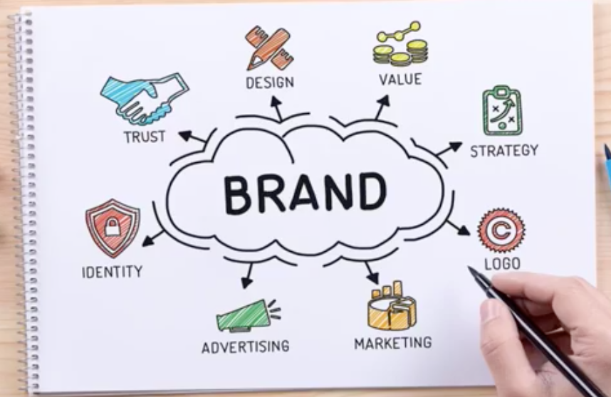

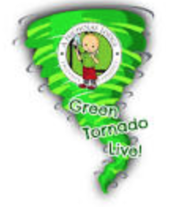
Nicholas Lodge… The Green Tornado himself will be joining….!!!!
Woohoo!

Ambition is the path to success.
Persistence is the vehicle you arrive in.

The BEST project you will ever WORK on
Is yourself.
David:
You’ve all got to week 4, which is a huge achievement- you SHOULD feel proud of yourselves!
Pricing (last week): Spread sheets, cash-flow, forecasts… It’s a toughie but you NEED to get head round it! It’s a crucial part of business and the business plan. The foundations of the business plan are based in the pricing so you must go back and complete it. Once got pricing sorted, now looking to elevate this by creating the brand.

Re-cap: W1: Setting objectives, confidence issues, getting positive.
W2: Mojo and time planning
W3: Pricing. Use the docs!

This is a fast-flowing business boot camp. Everyone may not make it But for those that do, the rewards will be out there. Takes grit and determination not everyone has.
(Nic on soon.)

Go and do your pricing homework!
What is branding?

We all have our own visual on what branding might be.
Branding is:
“The process of creating a strong, positive perception of your company and its products in your customer’s mind.” – Wiki.

Easily recognised well-known brands… Coca-cola, Google, Apple, Adidas, etc.

No better recognised brand in the cake industry than Chef Nicholas Lodge. Hand-over:

Chef Nic Lodge:
(NB: I’ve copied and pasted Chef Nicholas Lodge’s documents and added them to the bottom of this notes document for quick reference for you.)

- Self branding
- Re-branding
- Business branding
- Affiliations, ambassadorships with companies; good for those who teach, instructors, cake artists that go to competitions or do lots of lives, etc. Will help with things like financial support with products, endorsement payments.

2006, NL rebranded himself. At this point he’d been in the industry for 43 years. Not unlike well-known celebrities/ artists in the music industry who have to rebrand themselves in their personal style, change clothes, colours use, style eg clothes, but also music they put out. In our industry (cake, confectionary, cookies, pastries, etc) we have to do the same or will become complacent in that established persona we have. Being able to rebrand and refresh yourself will make a huge difference to:
- Yourself- morale
- Help visual appeal of brand- fresh and current

Be like a butterfly. Metamorphosis!

NL: 16 years old: started going to cake shows (British Sugarcraft Guild started). A lot of cake artists that presented then are no longer around (in the cake world). Sadly became burnt out or possibly complacent. Eg they’re teaching same content over again, so got left behind. If you cant offer your cust/student something new and refreshing, (class or product) they will go to someone else more on trend, fun, in fashion, etc who is.
Those of you been around a long time, you may be worth considering total rebrand if this is you.
- New name
- New Colour
- New YOU!
When Covid out of the way… Come back as new refreshing artist/ Store/ Company etc. Can do on little money. Painting a store can make a huge difference to customer’s impression when they walk through the door.

Self Branding.
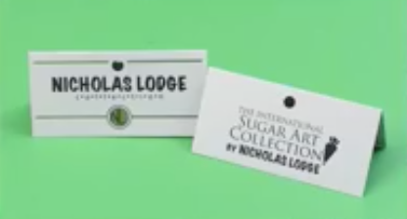
NL will post his personal story (England to USA and business changes, etc.) on the group.

NL Rebranding what talking about in 2006:
NL was using
International Sugar Art Collection
by Nicholas Lodge
and
The International School of Sugar Art.

Then, in Atlanta, when they first arrived 30 yrs ago, they were the first of its type. Now in UK, have Cake stuff, Cake Dec Company. But before then, in UK and USA, people very much independents manufacturing their products. NL Collection was to encompass lots of different brands. First to import patchwork cutters, FMM and other English companies, sold under the NL umbrella.
Moved to manufacturing own DVDs, booklets, equipment, they then rebranded within umbrella: Nicholas Collection. Had own brands within the collection.

Colours were cream and hunter green. In classroom, walls painted dark green with wallpaper border cream flower magnolia, etc. (prevalent in Atlanta). Decided didn’t like border in 2006 so ripped it off which kick-started redesign. In business have to be practical, so work with what you have- can’t start completely new. NL had white shelving units, grey tables in classroom Black, grey and white colour scheme. Wanted colour to add to that. Liked green but popular then to have bright colours. Favourite colour is orange but would give a Halloween scheme (with black, grey and white).

What NL did:
Got some paint samples. Good way to look at colours and consider colour palette you’re moving towards.
Loved green as soothing, but decided brighter green good- soothing but bright= more fun.

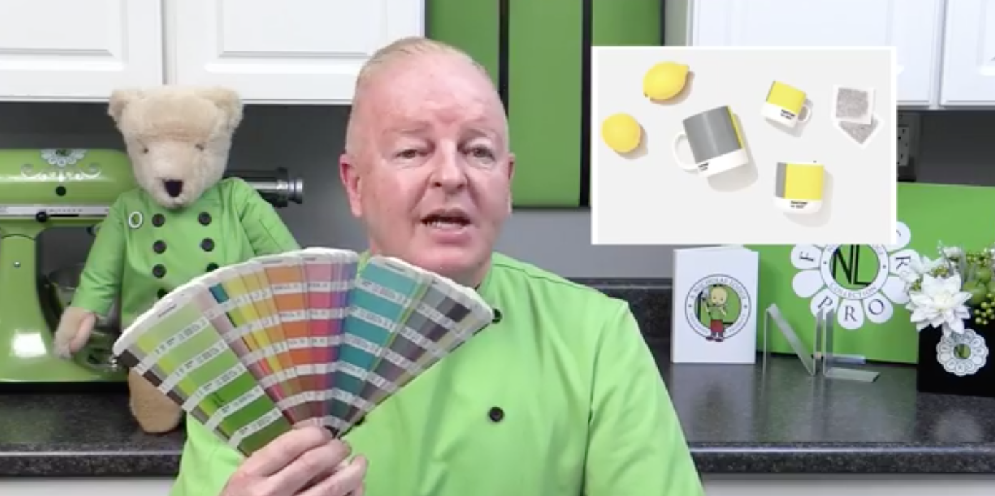
NL advice is to order a pantone book (£15-£30 second hand). (Looks like the paint chart strips like in B&Q).

They bring one new updated book out every year. Colours ‘in’ this year (usually announced in December for the following year) are ultra grey and illuminating yellow. Might be fun palette to consider. Fresh and clean colour combination.
Pantone colour is very influential in interior design and fashion. Make sure order pantone book for printed not fabrics and wallpapers; get the one a printer would use.
Each colour has a name and number eg. NL = Isa Green.Pantone 368C.
NL uses his pantone colour to get colour match when possible to create business cards- tell them the pantone number of it etc. Gets perfect colour match/ coordination. Consistency for labels, stationary, painting walls, etc.

Pantone book also great re using for wedding consulations. Eg which pink roses, bride bring in swatch and match to pantone colour. Also when having things manufactured, you can use pantone colour and ask them to use that to match. This makes consistency in colour printing: labels, stationary, painting walls= perfect colour match.

NL always carries his business card as it has his pantone colour on it. So when shopping (eg his kitchen aid) can quickly match things you can’t custom colour. Coordinated colours look clean. Not everything has to be the same tone, but business cards, etc need to be consistent and clean.

38C= known as “NL Green”; students etc message him with products in his colour that he might like. (Branding at work!!) Signature colour.

Colour is very much a part of our world:
Blend in (muted ) or stand out in a crowd (‘out there’)
Iconic Tiffany blue= recognise as Tiffany.
A way to separate yourself out from the crowd/more individual/ separate yourself from others.

NL, representing his brand usually wears his colour almost every day, in some capacity.
“Here’s Mr. Green, where’s he off to now”.
Creates questions/ conversation:
Irish? Why the green? Why not? Football team colours- do you support ‘x’. Good to b individual sometimes and colour is a good way to do that- think about accent colours in home décor.

It’s a colour NL doesn't tire of and chose a colour that won’t go out of trend in 3 years.

Investment into clothes (Chef’s jacket etc.) can cost quite a bit but can do over time, especially with custom-made items. Can get accessories in your colour.

Can put logo stickers on phone case, suitcase, etc.
Can create merchandise; face mask, tote bags, etc. Can do lots of fun things to whatever extent you want to use your logo/ colour.

First step: Think of a colour you like. Part of homework will be to come up with brand concept, a colour, potentially a simple logo.

Even though brand called NL, not just personal (about him) as sell and manufacture products as well as teaching. If you don’t make/sell products, may want to think more about more ‘you’ as a brand focus. As cake artist still need to think about branding for:
- Wedding show/ bridal show
- Meet with client
- Event space
- Deliver to hotel

Three ways to go about a logo
- Use your name. NL used monogram (NL)
- Business name. Doesn’t reflect you as much.
- Combine both: e.g. Sugar Treats by Cath Smith.

Personal Branding.
Advantage of using your name is that it’s simple. Some people have really weird names and people think how does that reflect what they do, what they sell, who is the person behind this…. Which you may want. If you want your name to be established, NL suggests use your own name or monogram.

To make it, can use software and apps.
A business logo very important part of your logo- it’s what has established you.
Can start by drawing out, can use apps, use professionals- graphic artist. They will draw to scale, get spacing correct etc.
Better for you to design the concept then take to a graphic artist and they will create your logo.
Use pantone colour (number), then can use for business card orders and other goods.
Can download logo as PDF to send to companies when ordering stationary, business cards, etc.
A lot of artists use their name. E.g. Lauren Kitchens LK Cakes for her cakes. Then for products she makes/sells = LK Collection.
Company name can stay the same (NL always used ISAC [acronym] International Sugar Art Collection) but with other brands coming under that umbrella.

Flower Pro (collaboration with Katy Sue Designs) incorporates NL branding inside gerbera daisy (Separate whist creating unity).
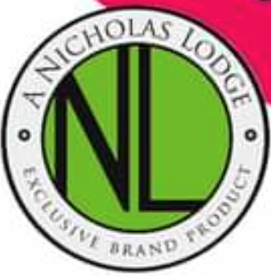
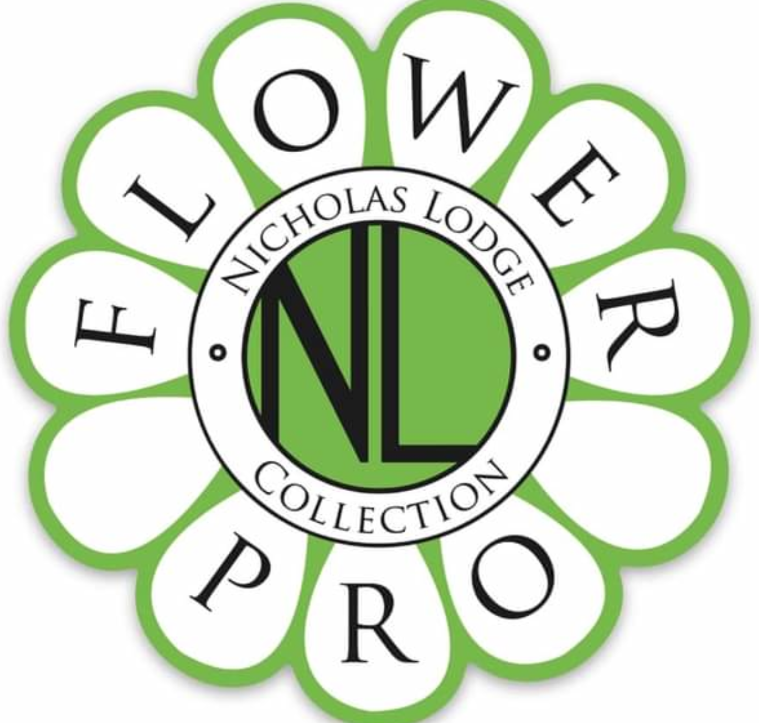

Business Name Branding.
For bakery, couture wedding cake business, etc.
Can change up, so add NL collection to Sugar Art Collection.
When chosen colours, try to be unique in choice of logo design, brand and colour. It should be a driect reflection of you as a person. Should be a colour that you’d wear, would suit you. Yellow doesn’t suit everyone!

Cake show pre-2000 = Nobody had a colour reflecting their business or themselves.
Typically white/ black tablecloths.
NL easy to find: bright green table cloths. Even Cake International, see bright green for Flower Pro area, walk down isles and bright greem stands out. Makes easy for people to identify you. Now is pretty standard; a lot of vendors use bright pink or certain colours to represent their brand.

Sydney Galpern: Yellow and Black (simi cakes) makes easy to identify her.

Steps: Colour, logo, tying it together.

Next: personal attire, etiquette, professionalism, ambassadorships, etc.

Personal Attire and Presentation.

Very important part of our industry eg:
- Meeting clients
- Going to cake show
- Entering a competition…
You’re representing your company and brand so it’s very important make a good impression.

“Is it ok to wear a chef’s jacket- I’m not a chef.”
Yes!
- Looks professional eg on hotel, events centre, delivering cakes, the caterer, photographer, florist when meeting clients, etc.
- Portrays a professional image of your company.

“Can I call myself a chef; I’m wearing a chef’s jacket?”

‘Chef’ isn’t a title you should be using straight out of culinary school. You don’t buy the title of chef- it’s earned… By respect from peers in your industry, accolades and also experience.

Professionalism = freshly pressed chef jacket makes impact and sets you apart from other competition.
Can choose a short sleeve, 2/3 sleeve, ¾ sleeve, long sleeve, etc. What you feel comfortable in. Competition/ judging jacket= the more formal long sleeve jacket. Keep in van and wear when delivering. Also use long sleeve jacket for wedding cake consults.

Competition/ judging jackets:
Entering/ judging competition/ TV show = often just apron. Don’t attach any logo patches or any other affiliate’s ambassador patches, pins etc. unless you’re given permission Often they’re sponsored and are plain with one or two design logos..

Disney Epcot food and wine festival jacket. Every chef provided a jacket by Disney. Front has food and wine festival logo which changes every year and on the sleeve is the Culinary Classics logo as they sponsored the jackets and manufactured them.

Don’t, when you get the jacket the day before, go ironing on your own company logo patches etc. The jacket is a canvas for the existing sponsorship etc.

When NL was at Satin Ice Competition, NL couldn’t attach his Renshaw patch at that event (direct competitor!)
NB: The picture used by NL has been taken with his NL green colour as a backdrop!

Can accessorise with your brand colour eg socks, lanyard, shoes etc. Some competitions, when jacket not provided, you can wear what you choose and bring your own jacket. You can add your own patches/ logos to jackets you’ve been given ONCE YOU TAKE THEM HOME!

For everyday work when not meeting with anyone, NL tends to work in a T-Shirt or just a basic black, inexpensive short sleeve chef’s jacket; again he puts his logo on these. (Not using custom-made jackets when he’s not going to see anyone!) Premium jackets wear for consult/delivery= £110- expensive! Can get cheap one online for £15. Patch company then makes your logo patch and add. Total cost around £20-£25.
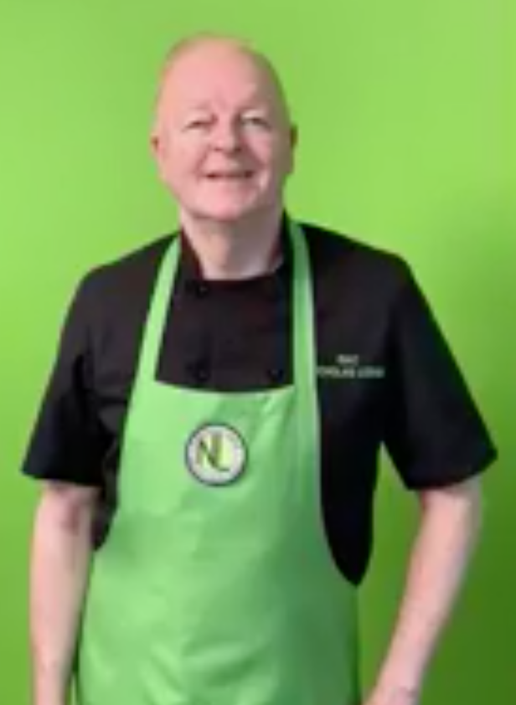
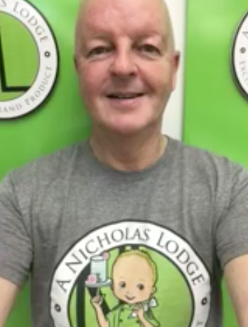

When working every day, baking, better to wear something comfortable that won’t get stained with food colouring etc. Also best to wear apron.

NL wears clogs. Suitable shoe for event. Professional and practical- not flip flops?!

Pastry kitchen: Professional pastry attire: clogs black trousers, white chef jacket, chef hat. Only brand related item (everything else uniform) = NL brand green socks to stand out a bit.. Student differentiated by skullcap.

Growing up in England with school uniforms, looks professional in classroom environment for instructors and students to look the same. Helps with whole professional look.

Endorsements, Ambassadors and Affiliate Programmes.

Good exposure
Potentially help with financial support: e.g. product support at your classes, support collaborations rather than having to buy the products yourself.
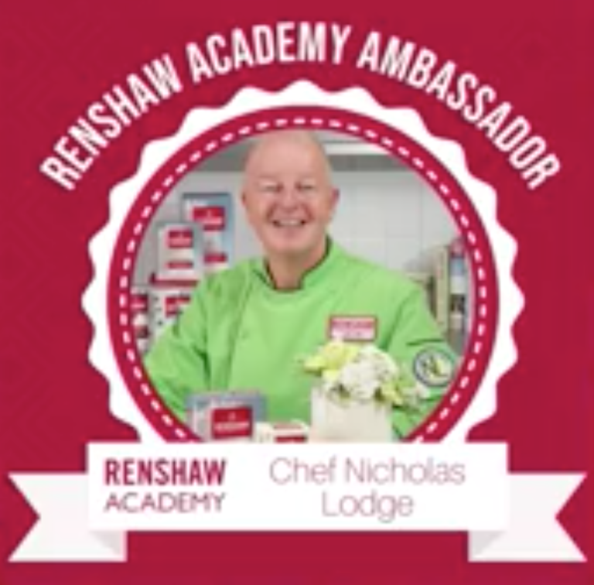
Many companies out will sponsor you for:
- Projects
- Classes
- Collaborations.
E.g. NL is brand ambassador for Renshaw (UK).
They have sugar paste, gum paste, marzipan
and other bakery related products.
Renshaw, like many companies sponsor events
worldwide; especially large installations when
renowned cake artists create large pieces
sponsored by companies such as Saracino,
Renshaw, etc.

There are dozens of companies that can support you for a cake show cake (providing the sugar paste to use on the cake), your competition piece or TV appearances where you want to use their products- or they want you to!
Win-win: They willingly give product in return for you promoting the company.

Lives/ Instagram etc can approach companies for products.
Ads/ endorsements/ big following on social media can create revenue.
When you love a product, tag a company’s name. Amazing what can come from this. Use something on a live, demo, online class and they contact saying love what you did with our product= produces a trade-off.

Can approach companies about affiliate programmes. Covid left artists at home so moved to online/ zoom/ Facebook lives. So NL contacted Arkon mounts. (Holds phone and iPad at same time for demos, lives, etc.)
Affiliate code. You promote using this code then when the person ordering, they get 20% and you get kick-back. Also great re getting free product.
NL well-known which snowballs potential opportunities so when approach companies, people know who he is. If you’re not yet well-known, tag them and let them see what a wonderful job you’re doing promoting their products. You can then reach out a week or so later, send them a copy of the live to build relationships.

Don’t feel shy about reaching out to companies. You can add their patches/ logo/ marketing materials on your Facebook page, website, etc. They have the marketing materials to show you work with them.
Kitchen Aid provide all mixers and pasta machines that NL needs in classroom etc. He’s worked with them for many years, which started from his Craftsy classes, which provided great exposure for Kitchen Aid. NL approached them about working better together and they were generous re mixers. Lots of companies have dozens of ambassadors: Sugar Flair, Satin Ice, etc., etc., etc. Some ambassadors for larger companies promote all their product range, whereas new, small, specialty company may only have one product they’re launching. You might be sought out if you’re specialist in the medium. Eg Emily Hankins for cake painting.

Make sure you only publicly endorse a product you really believe in. Students/ followers take what you say as gospel. Can’t say it’s a great product if you think t’s rubbish OR be chopping and changing eg between diff sugar paste brands every week. Not good for you or them. Sometimes a partnership doesn't work but part amicably. Don’t burn your bridges.

Find your niche. NL unsure at first; he didn’t foresee teaching. At 17 he decided he wanted to specialise and so only works with three mediums:
- Royal icing
- Sugar paste
- Sugar flowers

Can’t be a master of everything. You won’t be able to excel in any particular medium and when people are sourcing a specialist for a product they want to be endorsed, if you’re just a general cake artist and don’t have a specialty you stand less opportunity to be able to represent a particular brand what you support and teach with.

Note branding: NL ALWAYS signs off with “Sweet Wishes”.

David Brice: Summation.
Going for a change of brand can be quite challenging thing to get your head around.
NL used his name as his brand, which is a good way to go, whereas with Cakeflix, we’ve moved to something more generic (from Paul Bradford Sugarcraft School) to allow Cakeflix to be more inclusive and future more online. This is to give a feel of a company and group, bringing in cake artists rather than one individual. Paul is still the lead tutor and up front and central/ face of the brand but allowed us to incorporate and work with more artists without them feeling like they’re belittling themselves, working for someone else.

Part of problem when putting jigsaw together to have company name formally recognised, it’s not just about getting the domain name. (But this was a challenge for Cakeflix as .com already take and they want to be international, not just .co.uk) had to buy the URL name/ agree fee from photography company in L.A.

Make sure when building up by getting a logo. Make sure get the copyright for the logo. The graphic artist owns the copyright and sell a license to the user to use it. Don’t do this- get the copyright assigned to you.

Copyright important in terms of protecting the graphic art. But if want to protect your brand, need to get a trademark- can be expensive though and need one for each country you want to be an international brand. Cakeflix trademarked in UK, USA and Europe. This means their logo is protected but also the business. Have to specifically state what areas you’re protecting your business brand from. That said, to start with, copyright absolutely fine.

Branding and logos: Big companies done a great job and spent a lot of money to get their brands to where they want them to be. Hoovering verses vacuuming. Brand position (Hoover) to that level of brand recognition, you’ve really mastered it. (They then had a dodgy offer which impacted them later though!)
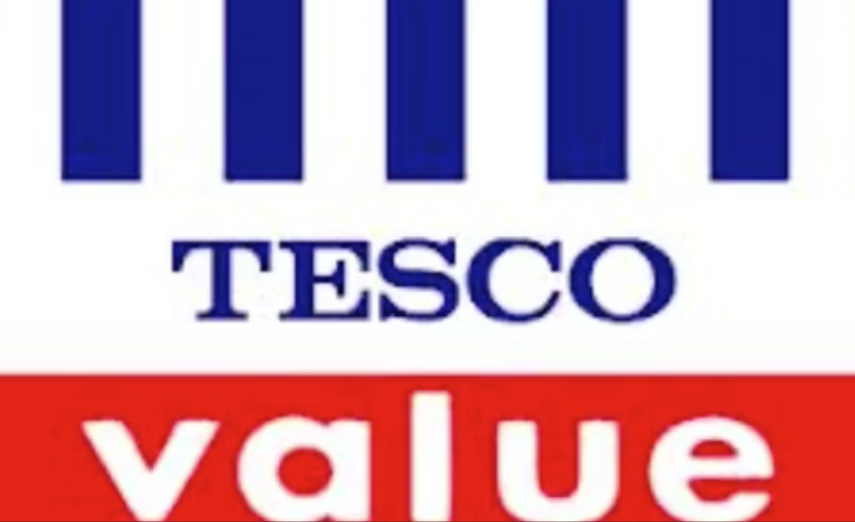
Simple branded colours
Red= clearly a deal on.
This tone of blue represents inexpensive/ offers/ value.

Storytime:
Trademarked brand. Sent a lot of money getting the L & V to work in that way. So they put it on all their handbags, merchandise. The name and colours are synonymous with quality.

Little cake shop start to use that LV brand, get a ‘cease and desist’ letter from them. On letter shows all the things they’ve protected themselves against through trademark. So…. You’re not going to copy them- you want to be unique anyway!

99 Designs (David & Paul used them.)have a bank of designers who will help you create your logo- a representation of your brand.
Rusty on pricing but £100-£200 ish, upfront fee. You then get access to designers in that category. The higher amount= higher quality graphic designers. You give them a brief including target audience (high end customers etc) and they’ll ask some very personal questions about you, your products, etc. They’re trained to put the jigsaw together and create some designs for you.
If you choose one of their logos, you get the copyright etc, but as soon as you click yes, they then get paid and you forfeit the right to any refund and the graphic designer gets their portion of that money. But up until that point you can ask for a full refund at any time so it’s not a bad exercise to go through because it will give you an indication of what a graphic designer will think of the ideas you have in your head.
Downloads will be on the Facebook group.

Homework:

- Come up with a brand concept. Your core values, what are the business core values, what’s the market place, target audience?
- Think about a logo, maybe think about your name, monogram, etc. Do searches on internet to make sure nobody has your name; someone else may have already bought the copyright for that name.
- Choose a colour. (Remember Pantone number) NL went through rebranding exercise- good enough for him, good enough for the rest of us.
- Overall feel look at the brand. Looking at sponsorships, endorsements etc. Write down if interested in approaching a sponsor, affiliate partner or endorsement, who would you choose? Companies you want to work with (as an ambassador). Start to approach and tag them.
Cakeflix has affiliate partners!! They’ll be inviting pro members soon, inviting them if they want to be affiliates of Cakeflix.
Questions:

Q: If create your own logo, do you own the copyright of it?
A: Yes…. But Copyright is not automatically yours. Make sure get it from designer. There are fairly inexpensive copyrighting services online for that extra validation. Or, if know a lawyer/ accounting you can send that material off to, with proof of the date, it then becomes incumbent to someone else that they’ve predated. You don’t want someone else to be taking you to court saying YOU’VE copied their idea when it was yours! Get the copyright registered.

Q: If go to graphic designer, they ask for logo to be made, do they have to ask for the copyright?
A: Yes you do! Make sure the terms are clear from the outset. The copyright belongs to the artist who creates the work. Most graphic designers will be transparent and aware that’s what’s happening, but there have been cases of companies being charged every time they want to use the logo, etc. You’re in a position of strength at the start of the negotiation because they want your business. Make sure it’s crystal clear and pointed out where in the contract that they relinquish all rights and it then belongs to you.

There’s a huge amount being thrown at you with boot camp, which is why David said need 4hrs per week minimum to consume this. Perhaps for pricing last week, should have broken it down- or you allow yourself 8-10 hours commitment for that. But, the material is there. Whilst all important the one you MUST GET RIGHT is last week’s work on pricing: Get the numbers right, cash flow right. Once got numbers right this is when the branding comes in.

Next week: WARNING! Marketing presentation. If you’re easily offended DO NOT tune in.
Sergeant Major Brice unapologetic! Good reasons for it!
With marketing, it is about application. There’ll be lots of hints and tips and new stuff thrown in. Sergeant major role is the best way to get the most amount of people through to the end of boot camp. David wants to hear stories within the next year of achievements we’ve made. Passionate approach from David is best way to do that.

(Never mind David…. Get passionate yourself! )

So far done:
Looked at the goals
Mojo, mindset and stepping stones
Pricing and cash flow planning
Branding we need to achieve those prices, med and long term goals.
Then next week= marketing plan that will bring pieces of jigsaw together and get you thinking. Cash flow planning, marketing plan are absolutely huge in getting you to where you want to be.

Will be a short, sharp shock next week!

Pro meeting chatter Q&A; 19.30 on Thursday.

DOCUMENTS FROM NL- COPIED & PASTED for your quick reference:

Nicholas Lodge “My Professional Business Journey”
In my career of 42 years I have had several brands and companies. Starting in the UK with “House of Sugarcraft” where we designed and launched the first FMM plastic cutters in a pale peach color, and a line dusting powders. All under the “House of Sugarcraft” brand. The company colors were pink, grey and white with a bakery window awning style logo. All very fitting at the time, which was decided upon between the business partner and myself. This line did well with distribution around the world.
After several years with “House of Sugarcraft” I made the decision to permanently relocate and move to Atlanta, Georgia USA. This decision was over thirty years ago. At that time, I found it difficult to continue with a UK based and operated business. I never felt the collection or logo said, “Nicholas Lodge.” Of course, I was very a young at the time. I was only 23 when I helped start “House of Sugarcraft” and if I knew then what I know now 35 years later, things would of course been quite different!
Next came “International Sugar Art Collection” (ISAC) started with Scott Ewing my partner. We were the first USA distributors of FMM, Patchwork Cutters, Holly Products, CelCakes and more.
We sold many collections of cake decorating related products, mostly from the UK. The collection related to the different companies’ products, all under one umbrella. At the time we were the first to carry all the main UK companies products in the USA, all available from one source. We started ISAC in collaboration with a retail cake decorating store and school called “Confectionary Yours,” located in Marietta, Georgia, close to Atlanta. I had been working with “Confectionary Yours” for a year before Scott and I started ISAC. Here we sold products both retail and wholesale through this operation and hosted classes there too. It was our base of operations and somewhere to store, pack and ship from, as well as teach classes, but without all of the responsibilities of having our own space. We paid a percentage of sales from the products and classes to the owners. This was a steppingstone in our business plan and something many people do in our industry, like host your classes or sell cakes through an already established business. The established business is responsible for the rent, payroll, insurance, security, upkeep and maintenance, etc.
Soon, we outgrew this arrangement and we rented a small apartment for the business. The kitchen was used for prepping for classes in making flower / gum paste, covering cake dummies and more. What would have been the living room was where erected shelving and we stored all of our inventory of products. The bedroom was storage space for all my teaching supplies. I would spend time there preparing for teaching trips all over the world, exhibitions and cake shows. We decided that we did not want the business to take over our house and keep it separate, which would prevent us from ever being able to escape from the “business.” The only part we had at home was the office that the formal dining room was converted into. This is where we would revive the orders, by telephone and at time, mostly via the fax machine. (LOL) Remember this was about 28 years ago, prior to the Internet, web sites online ordering, etc.
Scott would receive the orders from overnight and the morning and then make the five-minute drive to the apartment where he would pull the order, box it up and then take the completed orders to the post office or UPS station. During this time period we were actively looking for commercial space that was close by to lease.
After much searching, we began working with a commercial realtor (well worth it!) and found a 1,500 square foot space to move the business into. We were able to give up the apartment and regained our dining room and finally had everything under one roof! It was so exciting but also so scary at the same time, as it was now our responsibility to take care of many things including staff. Staff was and still is the largest business expense and often...the biggest headache of any small business! We have been very lucky with all of our amazing “Team ISAC” that we have brought onboard with us.
With ISAC we started small. When the opportunity presented itself eighteen months later, we took over another adjoining suite. Then another suite and another suite until we had over 7,000 square feet of space. This consisted of a total of four suites that featured a huge product retail gallery, my NL studio classroom, a second studio/classroom for hosting guest instructors, offices, photo studio, student’s lunchroom, kitchen and warehouse. Plus 4 themed toilets/restrooms
Our lease was up in the spring of 2020. Due to the current world-wide health crisis we made the very difficult decision to eliminate some of the retail, office and warehouse space and downsize our operation a bit, which is proving to have been a very wise decision!
A business model should be a direct reflection of yourself or your business. I believe ours is just that! Each area within our building has a theme. The student lunchroom features an Italian theme with a Tuscan bakery themed toilet/restroom.
My NL branded themed classroom joins up with a English garden retail gallery and a cupcake and gingerbread themed toilets. Finally Studio B was decorated with fun, bright citrus shades of oranges and yellows with a French chocolate themed toilet. . (We have the most photographed restrooms! I come across photos of our restroom all the time while doing Google searches.) The reason for all of this work, effort and expense is to create a warm, friendly and inviting space were our student and customers feel relaxed and happy to be here.
Over the years, especially before we opened our present location, I traveled and conducted classes all over the world. But sadly, most cake decorating supply stores and classrooms were very boring spaces, most being painted in a pale blue color. I do not understand why, as it felt like to me that I was in a hospital waiting room. This is a space intended to learn creative sugar arts in. So, when we opened our own space, we set out to make it different in so many ways! For example, from the minute the student arrives. until they depart, everything is provided for them. Morning muffins, breads, orange juice, hot tea, coffee, unlimited iced tea, coffee, bottled water, and soft drinks throughout the day. A lovely lunch with homemade bread made by Scott
every day. And at 3:00 each afternoon, a tea break with warm out of the oven homemade cookies.
In the classroom students are provided with every single item needed to participate in the class is provide for them to use. It is these personal touches that put us at the top of a ultimate classroom experience. An experience that students from all over the world, from six continents, have enjoyed! (We are still waiting for a student to arrive from Antarctica!)
In 2017 we started to see a decline in walk-in customers, sadly due to Internet companies like Amazon. We found that many of our customers had started ordering cake boards, drums and boxes for the convenience of having it delivered direct to their home of business. Also, there is a global decline in students who desire to attend hands-on class sessions. For this reason, we decided to downsize our space. Starting in 2019 and completed in the spring of 2020. We now have half the space, but also half the rent and have made the space more efficient. My original classroom held 20 students and at one time all hands-on classes were full with a waiting list. The reality of today’s classes is a smaller number of students. Now my teaching classroom comfortably accommodates 12 students. And is it generally believed in the crafting industry that 12 the new normal!
A business is constantly evolving and changing and must in order to survive. Now we realize most students want virtual classes. This makes me sad as I miss the contact and personal attention that I can give to each student. You can’t learn everything online. Sadly, skills like piping, you can show, but can’t teach, as I spend time with each student holding their hands, so they understand the pressure and angle that is needed to use, for superior results!
I hope one day soon students will appreciate the importance of a hands-on class experience and will return to the classroom, regardless of what it is they are attempting to learn. Be it cake decorating, sewing, cooking or furniture upholstery. For it is in the classroom where one can truly learn and hone their craft from the leaders and experts in their chosen fields.

Self Branding 1
Cakeflix Business Boot Camp Self-Branding, Business Branding, Brand Color, Logo, Endorsements and Sponsorship
Branding: Personal branding, business branding or rebranding is something you may want to consider as part of your new or existing business plan and set up.
In 2006 I decided to rebrand myself as I have been involved in the cake and pastry industry for over four decades.
Just like a musician or singer, like Cher, Madonna and Elton John, they must reinvent and rebrand themselves in image, music and style to stay complacent in the market. As a sugar, cake or cookie artist our businesses are no different.
It’s sad for me to think about all the artists and companies who are much younger or had a business for less time than me not being around anymore. Of course, that can be due to many factors such as burn out, ill health or personal circumstances. But many are gone because they felt okay with where they were as far as what they taught, created, manufactured, etc. but never tried anything new. They never taught any new class material or manufactured new exciting products. So eventually no one desired to learn or buy from them as it was “the same old thing” and often out of style or no longer in trend.
I have reinvented myself several times during my career and you can read my story at the end of this download of how I started and the many different steppingstones I took to build and reach a successful business. (Well not so much currently due to the current world-wide health crisis and pandemic. But let’s hope things improve for us all very soon.
Self-Branding: In 1990 I relocated from the UK to Atlanta, Georgia and in 1992 I started the International Sugar Art Collection, (ISAC) and used the Original International Sugar Art Collection by Nicholas Lodge and the International School of Sugar Art logo until 2006. The original company colors were cream and dark green. In my classroom I used a southern magnolia theme wallpaper border. One day in 2006 I just decided to “rip-off” the border and make a fresh start.
At that time the classroom had new grey tables and that was the starting point. So, I settled on a combination of black, grey and white with an additional focal point color. Ever since I was a young child, I have always loved orange as my favorite color. But orange just did not work and was very “Halloween looking” especially if the walls were painted orange. So, I gathered paint samples and decided on a shade of bright apple green, now known to many as “Nicholas Lodge Green.”
If you are interested in choosing a brand color for yourself, I would suggest that you order a Pantone book used for printing. This booklet of color swatches is a universal color matching system used by printers to enable them to color match. I purchased one that was used on eBay, as a new one in on the expensive side, but I use it so often and so much for a multitude of projects, even now 15 years later.
The Pantone color books are updated and every year a new Pantone color is announced. This year there are 2 Ultra Grey and Illuminating Yellow as the colors of the year. This new combination might be the perfect color for some of you to use for your brand color.
The great advantage of having a Pantone color is when ordering business cards, stationary, printing labels, choosing paint, etc. By using a Pantone color, you will get a perfect color match each time.
Of course, when I make purchases, I try to obtain them as close as possible to my accent color. I as always have my business card with me to help with the color matching.
My accent color is a shade of apple green, but not just any green but Pantone number 368C was chosen has as become my signature brand color. This was a huge change for me in color, but color is part of our world and makes us blend in or stand out in the crowd, and Pantone 368C defiantly makes me stand out! A big business like “Tiffany and Co.” has the iconic “Tiffany Blue.” I have “Nicholas Lodge Green.”
By using a color, whatever it may be, is a great way to define and separate yourself from the crowd. My students and followers on Facebook, Instagram, etc. associate me with this color. It’s my signature color that I wear every day in some form or another. And strange as it sounds, I never tire of it! And of course, I always wear this color at cake shows, when teaching, traveling, etc. As such, I’m recognized all the time by the Atlanta airport security saying, “There is Mr. Green, flying out again.” And by flight crews all over the world as well.
My clothing is mixed with grey, white and black, just as in my classroom, and in a more casual way with jeans, or for formal affairs and occasions i have dinner jackets and tuxedos in this apple green color too.
i own close to 200 pairs of shoes and dozens of these are in my signature green color. Some have been custom made, yes, a luxury, but it makes me stand out. In travelling I get stopped all the time by people commenting on my luggage, my shoes, what I’m wearing, etc. Often, they ask if I am Irish? Or do I support Notre Dame? And sometimes when asked, “Why the green?” and I respond, “Why not?’
After brand color came a new logo. My business is multi-faceted as I manufacture products as well as teach. It was not just me; it was my brand of products too.
In my opinion, there are three avenues to go about in designing a logo. The first is to use your name, or in my case, initials in the form of a monogram. Second, come up with a business name. This will not reflect you so much but your business. And third, combine both, like “Deliciously Scrumptious Cakes by Rosalind Lodge.”
I love how my current logo turned out. I designed it myself and then used a graphic artist to create a professional version in both the JPEG and PNG formats. This logo says it all and I couldn’t be happier!
There are software and apps available to help you with this task, but personally I believe this is an important part of your business and brand and I would advise working with a graphic artist to create the final version of your logo.
I think as an cake, cookie or flower artist, the use of your name is a good idea as helps to keep your name out there. Lauren Kitchens, a cake artist friend in Dallas, Texas uses her name for her cake business and her product line she developed is sold under the “LK Collection” name.
We call our business “ISAC“ which is the acronym for “International Sugar Art Collection.” But within that company we have several umbrellas; “NL Exclusive Brand Products,” and “NL Flower Pro” were we inserted the “NL” into the Flower Pro logo to look like a daisy.
My little child-like NL logo was designed by the uber talented Sachiko Windebel. She created this rendering of a much younger me wearing my Renshaw teaching uniform. I adore this logo and feature it on tote bags, tee-shirts, etc. It’s fun and I use it for my “Green Tornado” logo for a series of video demonstrations in 2019 on CakeFlix. Of course, I had stickers created with both the “NL Brand” and “NL Flower Pro” logos and I use these stickers on many personal items. Remember, it’s all about the brand!
Business Branding: Twelve years ago we rebranded and separated our product lines to include the ‘NL Collection” and the “NL Exclusive Brand Collection.” This was for exclusive brand collection that was manufactured, designed or acquired as part of the collection. This takes time and resources but makes you stand out at cake shows and conventions. Needless to say, everything is in my brand colors!
Try and be unique in your choice of logo, brand, color choice, etc. as it should reflect you as an individual, your work and your bakery or business. At the cake shows held prior to the new Millennium, I would say there was no one in our industry who had a color reflecting their business or self. Now everyone and every vendor has adopted a look, logo and color. I’m not saying it happened because of me, but feel I influenced many people in our industry to be more bold with color.
When you attend a cake show it’s easy to find me and my NL brand of products. Just look for the green tablecloths! Even at the “Cake International” show in the UK it’s easy to find the
“Flower Pro” and Chef Nicholas Lodge apple-green aisle. And companies like “Simi Cakes,” have the same draw. Whenever you see yellow and black you think Sidney Galpern and “Simi Cakes.”
Personal Attire: I personally have no problem with anyone wearing a chef’s jacket. It’s like anyone could buy and put on a judo suit. A chef’s jacket is like any uniform. It demonstrates professionalism. But at the end of the day it’s up to you to prove that you are a true cake and pastry professional to your peers, clients and family. The title “Chef” cannot be bought. It must be earned! Even after graduating from a pastry program the title of “Chef” is not usually used. The title “Chef” from hard work, industry accolades and respect. Most importantly, by your peers in the industry over many years. It is a sign of respect, like the way we address any professional.
Professionalism is a very important part of our industry. Your business attire, like a freshly pressed chefs jacket when you make a cake delivery, are touches that set you apart from your competition. Here you can see the type of jacket I would suggest wearing for a cake delivery or consultation with a potential client. You may choose long or 2/3 or 3/4 sleeve which is a little more formal than a short sleeve jacket as you can see here with competition or judging jackets.
If you are entering or judging a competition and you are provided with a chefs jacket, you must not attach any logo patches or any other affiliate / ambassador patches, pins, metals, etc. to the jacket unless you are given permission. These jackets, due to sponsorship of the competition, are usually very plain with one perhaps two logos. Here you can see my jacket from the “Walt Disney World Epcot Food & Wine Festival.” The food and wine festival logo is on the front of the jacket along with “Culinary Classics” who sponsored the chefs jackets.
For example, if “Satin Ice” sponsored a competition and I was judging, I could not wear a “Renshaw” patch on my jacket.
These jackets were all provided for me to wear. After the event you may add your own patches and accessories to them and have them made into short or 2/3 length sleeve, as competition jackets are almost always long sleeve, as this looks more professional but not as comfortable as a short sleeve jacket.
Due to the current pandemic, with more free time on my hands, I had a big clear out of my closets and disposed of over 100 chefs jackets, including 27 “Food Network” jackets from judging the “Food Network Challenges” over the years.
For everyday work when I’m not meeting with anyone or teaching, I work in a tee-shirt, with my brand logo of course, or a basic short sleeve chef jacket and apron. I prefer short sleeve jackets as I personally find them more comfortable.
When conducting classes and teaching I wear a short sleeve chefs’ jacket with an apron. I have my own NL brand of chefs wear for the whole family, with my logo patch and name. This collection is available through “Cake Wear” at: www.cakeweartx.com
Info@cakeweartx.com
As a chef, when I’m in a pastry kitchen, I wear professional attire like black Danskos clogs, black pants and a white chef’s jacket. But I stand out by wearing NL green socks, which is the only thing I can change.
As a chef instructor at the “French Pastry School,” (you see here my uniform,) all chefs and students wear the same jacket, just the toque for the chefs and our interns and skull caps for the students (when class is in progress.) It’s like growing up in the UK, where all the school students wore the same uniform, so everyone looks the same. Time has proven, this is very smart!

Endorsements/ Ambassador and Affiliate Programs
There are many companies out there who will sponsor you for projects, classes and collaborations.
I’m the brand ambassador for “Renshaw” the world’s largest and oldest manufacturer of rolled fondant, gumpaste, marzipan and other bakery related products.
Renshaw sponsors events around the world and many cake shows in the UK and USA feature large installations where incredible sugar artists like Emma Jayne and companies like “Magic Chocolate” do the same with artists like Daniel Dieguez.
There are dozens of companies who can help support you for a cake show cake, competitions and cake-war types of shows, so reach out to them. You may get offered free product for endorsement in a class, online class, etc. Someone like “Sweet Ambs,” Amber Spegiel is able to do what she does through adds and endorsement on her Facebook page. Endorsements are now not just for athletes! It can be for us all! Use a product, love a product and the company and it’s amazing what could potentially happen.
You can approach companies about affiliate programs. I desired to use a “Arkon” mount in my live demonstrations. I contacted them about possibly becoming a brand affiliate. They were delighted and sent me the “Arkon” mount at no charge and a brand affiliate link and embroidered patch. (See video.) The provided link means that anyone ordering from the link that you post will get you a percentage of the sale. I have worked with many companies like this, but remember I’m very well known in our industry and the pastry arena so when I approach a company, I have a track record. When starting out, say you do a video or live demonstration and use a product, mention the product several times and see what the feedback is by tagging the product, the manufacturer, etc. That will send a message and then follow up with them.
About working together. Don't feel shy to reach out and ask if you could work together and inquire if you could get a patch for your chef’s jacket or apron. (See video.) I am also an ambassador for “Kitchen Aid” and they supply me with the mixers and pasta attachments I need for my school as well as award prizes for cake shows I’m a part of. (See video.)
I’m also part of the “Culinary Council” for “Nielsen Massey Vanillas.”
There are lots of companies like Renshaw, Satin Ice, Sarachino, Magic Colors, Sugar Press that have dozens of ambassadors. And companies like Sugarin that have Sugarin brands that are chosen based on the artists expertise in the sugar arts. Artist like Serdar Yenner has a pastillage, and Karen Portaleo is about to launch a line of paints. These are artists who have a brand rather than say Satin Ice who have dozens of brand ambassadors who support the Satin Ice brand. If you are more specific to a certain technique or medium, you might need to find a smaller company to support you with product. In return, you promote them as your brand of choice.
But remember to be true to yourself and your art! When a company provides you with free product, you must believe in the product. Your students, fans and followers will look to you for advice. Never endorse something you don’t like or use. By doing so that is a recipe for failure, and your peers will not respect you.
In my professional life I have represented brands that I no longer am able to endorse. A few years back I was working with a large US pastry distributor promoting and helping to develop a range of rolled fondant / sugar paste, gum paste / flower paste, and colors. We were the first food related company in the world to bring out a trend color each year. This color was usually based on the “Pantone Color of the Year.” Now, many fondant companies do this. This organization was focused on the professional pastry chef, hotel and cruise industry. Unfortunately, they were unable to scale-down and provide for the home baker or small business by having products packaged into smaller retail packs. As such, we decided to part ways, but that was only a difference of opinion. Today, I still have a wonderful working business relationship with this company and the many people I worked with there.
Another time I was approached by a company wanting to make my gumpaste and all seemed well until the product became inconsistent. With my name on the package it was a decision to do a cease and desist. Again, it was a mutual agreement and sadly these things do happen. My advice is move on and do not say or post unprofessional things about what has happened for the world to read on social media. It is not being a professional to air your laundry and does not look good to other future prospective companies that may be considering you as an artist to work with them or ask you to create a line with them.
You are an ambassador for yourself and you never know who is reading your posts or observing you at a cake show. You must keep it professional all the time you are in public. Our industry is very small and if you do not do a good job teaching a class or demonstrating at a show other instructors, shop owners and cake show organizers will hear about it. If you burn bridges along the way you will indeed have a short career. And remember to always be respectful to those who traveled the same path and came before you.
Also, most things have been done before, like fashion. Don’t post, “I invented this!” until you have done your homework and make sure it’s an original method, recipe or concept.
Another little bit of advice is that you cannot be a master of every technique. It’s best to concentrate on a single or couple of techniques as you stand a better chance of being picked up by a company looking for an expert in a particular medium or field. For example, if I was bringing out some paint colors for cakes, Emily Hankins is who comes to mind. She is an expert in one medium, that she excels at, and does it to the highest level. Or a company bringing out a modeling paste, Sachiko Windebel is who I would approach to work with as that’s what Sachiko does, with incredible ease, as that is her specialty.
I only use 3 mediums gumpaste/ flower paste, rolled fondant /sugar paste and royal icing.
I do not air brush, do sculpted cakes, do figure modeling, work with modeling chocolate and many other techniques. I decided at 16 years old I needed to find a part of cake and pastry that I wanted to excel at and not try to master everything. When someone wants to learn a certain technique, they go to a specialist. Just like a medical general practitioner has an overall knowledge of the medical field but would send you to a specialist when needed for a certain condition.
Homework Business boot camp homework
Create your brand concept Logo Color Overall Look and feel
Sponsorship / endorsement / affiliate partner
Companies you would like to possibly work with and represent their brand in some capacity.
I hope you have enjoyed this session and found it inspiring and informative. I have shared a lot of information with you and hopefully it will help you in some small way, taking you to the next step in your chosen career.
Hope you all are very successful in your new or existing business plan! Till next time, Sweet wishes, Nx💚

