**Cakeflix Pro Business Bootcamp.**

**Week 2: 12.01.21**

**MOJO, Time Management and Business Plan.**

**“Ambition** is the path to success.

**Persistence** is the vehicle you arrive in.”



Compare to last week:

On a scale of 1-10 how positive do you feel about your business?

**Me: 4**. Not done what I need to do and unsure about direction.

Some great SMART objectives shared, whether written or not- looking good guys!

A lot for first time… With smart objectives they’re about getting to where you need to go.

**Today** going to start building back some milestones so work out what you need to do and when.

Chef Nic Lodge (AKA “The Green Tornado” coming to do branding presentation- YAY!)

**Bootcamp Rule:**

Stay positive in the group. **BOOT CAMP is our little positive oasis.**

Any probs, contact David. Don’t add to any fires! No neggy nellies, please!

Take the positives that fit with you and don’t discourage others, unwittingly.

**We’re about RESULTS!**

**D&P Crazy road trip….**

Use otherwise ‘dead’ time for business planning; car rides etc.!

* Perfect time to bounce ideas too, if the companion is a positive/ good choice to aid you and your business.
* Could listen to ‘The Secret’ or other YouTube informative/ motivational stuffs.

A **dream** written down with **date** becomes a **goal**.

A **goal** broken down into **steps** becomes a **plan**.

A **plan** backed by **action** becomes **reality**.

Today= break down into little steps, the long term goals from last week.

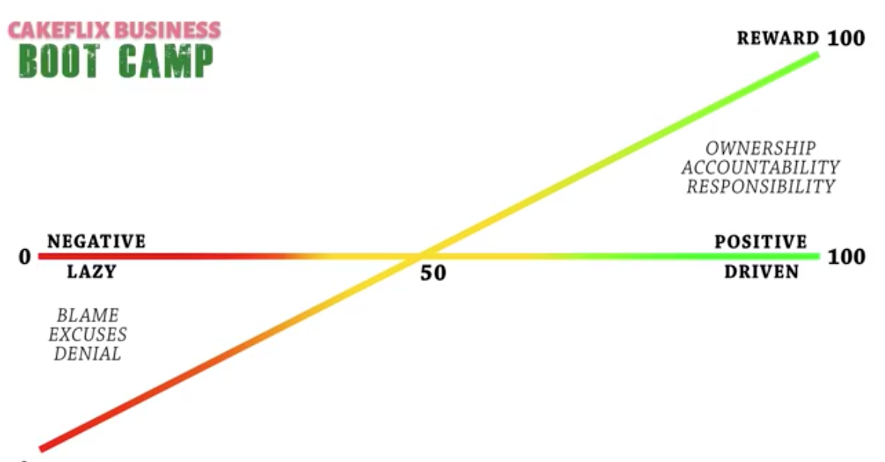

0 (lazy)-100 (driven) = 20

0 (Effort)- 100 (reward) = 10?! (Ridiculous levels of procrastination and second-guessing self!)

Are you working above the line or beneath the line?

Ask yourself these questions (0-100) above **regularly** and you’ll find you’re getting the **results** specifically, that **reflect** the **level** you’re working at.

**MOJO: WHAT IS IT?**

**Mojo is defined as a good luck charm or a skill that seems to come from something magic or supernatural.**

Where does it come from?

Deep down in your soul. Below conscious/ subconscious mind; gut instinct/ gut reactions etc.

Lots to do to impact conscious/subconscious mind. NLP, CBT, other alt therapies to help break barriers. Mojo a lot deeper.

If we DON’T have the mojo…. How do we get mojo back? Key issue cake artist= seeking perfection.

**Paul’s phrase: “Step away from the cake.”**

Seek excellence not perfection. If constantly chasing perfection, you’ll know about and hold onto flaws no one else will notice.

Paul lost mojo 4 times in last 15 years. (As a cake artist, he’d lost his ‘gift of design’.)

Go on hol, rela and chill out (get distance?) and without discussing, felt less ‘blocked’… found himself synapses snapping, grabbing random paper and pen to sketch out designs.

What happened= blockage of design ideas. Very busy, very pressured, summer= wedding orders/shows then Christmas; either lots of work or no work and wage bill.

Something blocks design ideas and gets ‘busy’ (mentally and physically with orders) which causes pressure(s). Find your way of removing that blockage. Paul would take some time out; go on holiday.

Some argue= no time to take time out. David says You can’t afford not to. The 2 weeks fuelled Paul for the rest of the year. If pushed, pressured, hurried with design, doesn’t work.

Pushing and adding more pressure isn’t likely to relieve the blockage!

**Causes of lost MOJO:**

1. Cakeflix TV Caking all over the world

2. People (cake artists) more at home and Paul compare himself unreasonably (eg one photo with whole week’s work on, verses Paul’s) Worry technical ability weaker than theirs.

3. Troll regarding free content- hard time over cake artists giving free content to Cakeflix. (No cash made, actually, Mr.Troll; just brand-building exercise.)

Resulted in less ‘Paul’ videos. He was still managing other artists/ presenting/ doing other parts of his job, but didn’t want to get in front of the camera. Because he didn’t fully step away, (still managing/ involved, etc) it took longer to regain mojo.

Step back: What’s the cakeflix brand and Paul about? Cakeflix core value/ Paul’s about: wow factor cakes that are commercially viable, at a time and a cost that makes them profitable. Suspend Cakeflix cake community page. Great audience but not adding to the brand. In fact, negative impact = impacted not just Paul but also member’s mojo.

**If struggling with mojo:**



**Look at the picture (or another relaxing one you prefer!)**

**Put on your favourite piece of music, enjoy feeling calm.**

**Put troubles aside. Forget the here and now; the emails etc.**

**Just look at the picture.**

**Serenity.**

**Changes the gear cogs in the brain.**

Advice from coach: Lock Paul in a room for 2/3 days. Let him come up with a design on his own that isn’t focussed on customers, just something he wants to do, something he gets excited and inspired about. (Paul came up with huge dragon design.)

**To clear the blockage, you need to change your actions. Change your actions you change reactions, change your thinking, change your mojo.**

**We set SMART objectives last week. Need mojo to put into action/tackle.**



Business is like a jet taking off. **Most fuel/energy is used on the take-off.**

When in cruise= little energy.

Getting from the runway and as inclines it **can get steeper** or **level out.**

**Your destination is your goal.**

To get there you have to take off.

How **vertical the take-off is depends on how far you’ve got to go for that goal**.

Get mentally strong before taking off.

**Time Management. (28 min.40 sec.)**

We all struggle with it from time to time, which is why a business goal should include work-life balance. No one wants to be the richest person in the graveyard. What’s the point in working 80-90 hours a week, while relationships etc. suffer? You’ve lost everybody in the process. So ensure a work-life balance element.

Balance work/ family time. Know why you’re working. Who benefits?

(SMART) Target= earn x amount (financial/business/monetary goal)

… for 40 hours per week. (work-LIFE balance element)

That’s the target. Doesn’t mean stop after 40 hours, leave cakes half made!...work times fluctuate eg seasons.

Time Management quadrant/ matrix:

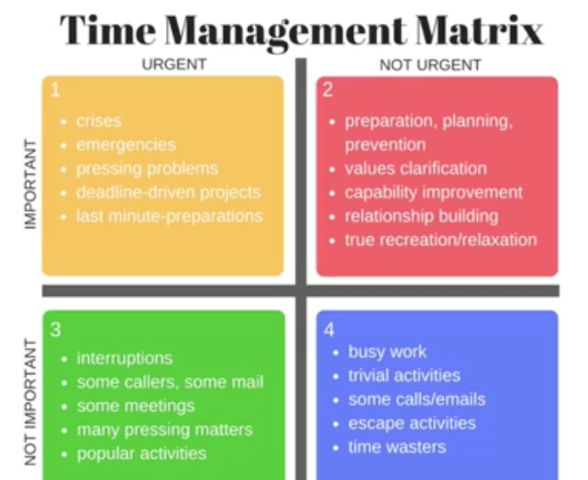

**Cake next week.**

**Not urgent but important.**

**Customer Enquiries: Urgent & Important**

**Distractions through social media.**

**Not urgent or important- Bin/delegate!**

David eg’s:

**Customer enquiries: Urgent and important**

**Cake next week: Not urgent but not important.**

**Distractions through social media: Not urgent, not important. Get rid of that! (Delegate where you can.)**

You’ve got to be aware of the **bigger picture**. Eg Paul and David’s contract. Best move was re-reading the contract as had got bogged down with wording and not noticed the magazine people had changed the first part of the contract, to make Paul their slave to create content for their magazine. Don’t be too driven by other people’s deadlines. **How** you spend your time is key. Decide your primary goals e.g. customer satisfaction primary for Cakeflix as they always said they’d respond 365 days a year…. So David plans his day:

First thing in am, scan what’s come in. Customer support= urgent and important.

Not urgent but important. Through day he doesn't look at a phone call or an email. Whoever wants to phone him, he ignores as they’re taking him into their time management, not his. And choosy over meetings he takes; what he thinks is good for him not what someone else thinks is good for him.

**Practise using the quadrant yourself. When things come n, put them under a hearding. Use to help organise and prioritise your day.**

**Business Plan. (39 mins)**

Trust David in the process. Last week = SMART target. David example will be for a three year objective. (Eg to be earning a profit of x, working x, by doing x (eg wedding cakes).

**Three key things to success:**

**1. Mindset**

**2. Goals**

**3. Flight plan.**

**Key objectives are the route (mini plans).**

**Should be three:**

1. **Action plan. This WILL change. Write in pencil.**
2. **Cashflow- pricing, etc.**
3. **Marketing plan- to achieve the numbers.**

**Written Homework Today:**

Complete the Cakeflix Action Plan sheet (Copy at end of doc. from Pro section of Cakeflix.com website [pro dropdown -> “downloads” -> action plan]):

**START HERE**

**(36 months)**

Within 36 months (3 yrs) **SMART** objective in here. (Main objective)

**Then**

**Work**

**Backwards**

Within 24 months (2 yrs) Have a good **milestone**/ check point here.

Within 12 months (1 yr)

Within 6 months

**END HERE**

**(3 months)**

**Bringing the goal in closer/ nearer**

Within 3 months

**WAGOLL By David:**

36 months= Earn £40k, working 40 hours per week.

… so

24 months = £20k, working 45 hours per week,

12 months = eg start trading 1st Jan 2021, what would be your profit and how many hours would you need to do in order to achieve the target you’ve set for 3 years time?

**Break it down, bring the targets in closer.**

If creating this action plan scares you (competency) get help! David/Paul partnership= different strengths. Paul = Artistic v David = Logical.

Don’t have to do it all yourself- D&P get a check in annually with a business coach. Can be a family friend partner- someone you trust. Get someone to hold you accountable and challenge you on where you are against your objectives re milestones.

Can create own spread sheet.

**Action required Priority By Responsible Comments**

**1-10** **(date)** **(Who?)**

Being held accountable=

get someone you trust

to hold you to account.

NOT just yourself?!

When working out your plan, start looking at steps.

What do I need to do in three months to get to where I need to be in 3 years?

It’s about bringing the business plan together bit by bit.

What are we using this plan **for???**- **make it useful!!**

**97%** businesses that **fail**, don’t have a business plan.

Very similar re businesses that **don’t** **regularly** **look at**, **adjust** and **adhere** their plan.

It’s not a sparkly bit of paper to feel good/ like you’ve done something. (It’s not a revision timetable you never use, but colour in and make look pretty!)

Without function/ USING it effectively and being held to account, you’re back n the 97% of failing businesses camp! It’s got to be a working document.

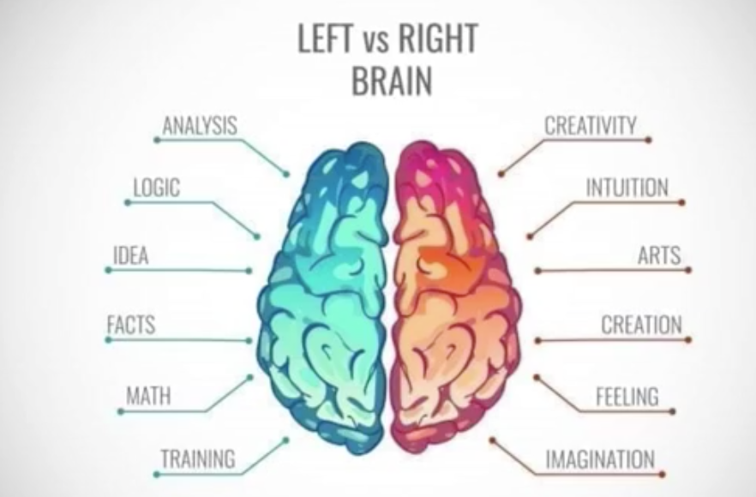

**Homework:**

Written: Complete the sheet outlining what you’ll

do in the periods: 3, 6, 12, 24, 36 months.

Videos to watch:

1. “Believe in Yourself”

by Grossman & Thomas

1. “Excellence in place of Perfection”

Blog post- psychologytoday.com: Nine Joys of Being Imperfect.

3. YouTube: Writing a Business Plan https://www.youtube.com/watch?v=Fqch5OrUPvA

Member Q: Finance: Sole trader= profit = income (minus expenses). Complete self-assessment. Whereas Ltd co, you are an employee of the company.

Keep business accounting separate; separate account purely for business.

Be aware Spring-Sept= busy then dips; budget for this.

Pro icon download: Can see turnover tracked over ten years by David. Can use as a guide for what can expect re fluctuations.

Accountant= use one free hour to answer Q’s.

Book-keeper = £15 an hour.

Sheet for homework:



**ACTION PLAN**

**Business Details**

|  |  |
| --- | --- |
| **Name of Business** |  |
| **Principle Owner** |  |
| **Address** |  |
| **Postcode** |  |
| **Telephone Number** |  |
| **Website** |  |
| **E-mail** |  |
| **Legal Status** |  |

**Creating the Brand**

|  |  |
| --- | --- |
| **Nature of Business** |  |
| **In a simple succinct statement state the aim of your business** |  |
| **List your brand’s core values** |  |
|  |  |
| **Explain your target audience** |  |
|  |  |
| **Explain the key characteristics**  **of your brand. What colours,**  **design, status of customer,**  **on trend, steady, designer,**  **economical, top level pricing,**  **your status, experience, expertise. Check out that these characteristics are aligned with your key business Goals and Objectives.** |  |

© CakeFlix Ltd



**Business Objectives – view this daily**

**Create SMART Objectives – Specific, Measurable, Achievable, Realistic & Time bound**

|  |  |
| --- | --- |
| **Within 3 months** |  |
| **Within 6 months** |  |
| **Within 12 months** |  |
| **Within 24 months** |  |
| **Within 36 months** |  |

© CakeFlix Ltd



**The Competition**

|  |  |  |  |
| --- | --- | --- | --- |
| **Name of Business** | **Describe what they do well** | **Describe what they could improve on** | **Marks out of 10** |
|  |  |  |  |
|  |  |  |  |
|  |  |  |  |
|  |  |  |  |

**Capacity**

|  |  |
| --- | --- |
| **How much time can you give to the business each week?** |  |
| **How much time will be taken up by admin?**  **i.e. ordering stock, taking orders, marketing, bookkeeping, delivering** |  |
| **How much time does that leave for cakes?** |  |
| **How long does it take to make a birthday cake from start to finish?** |  |
| **And a wedding Cake?** |  |
| **How many cakes can you make at full capacity?** | 1. **Birthday** 2. **Wedding** |

© CakeFlix Ltd



**Marketing Plan**

|  |  |  |  |  |  |
| --- | --- | --- | --- | --- | --- |
| **Activity** | **Start** | **Live** | **Cost** | **Measure** | **Comments** |
| **e.g. Competition local paper** | **01/04/10** | **01/05/10** | **£200** | **Promo code 1** | **Win a wedding cake. Code ‘1’ 10% OFF.** |
|  |  |  |  |  |  |
|  |  |  |  |  |  |
|  |  |  |  |  |  |
|  |  |  |  |  |  |
|  |  |  |  |  |  |
|  |  |  |  |  |  |
|  |  |  |  |  |  |

**Admin and Compliance**

* **Environmental Health**
* **Insurance**
* **Business bank account**
* **Approval from lender if property is mortgaged**
* **HMRC**
* **Suppliers**
* **Other….**

**Plan of Action**

|  |  |  |  |  |
| --- | --- | --- | --- | --- |
| **Action Required** | **Priority**  **1:10** | **By [date]** | **Responsible** | **Comments** |
|  |  |  |  |  |
|  |  |  |  |  |
|  |  |  |  |  |
|  |  |  |  |  |
|  |  |  |  |  |
|  |  |  |  |  |

DATE FOR REVIEW: ________________________________________________________

TO BE REVIEWED BY: ______________________________________________________

© CakeFlix Ltd