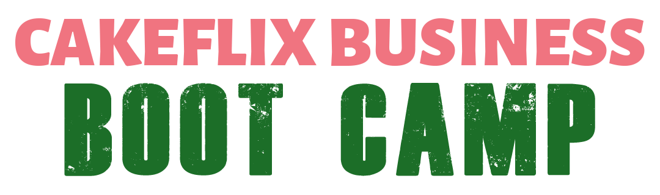
BUSINESS ACTION PLAN
Business Name:
Principle Owner:
Key Business SMART Objectives:
(to include what you want to earn working how many hours and by what date. Include personal objectives, award etc as separate objectives)
Elevator Statement:
(1 minute promotional statement)
Financials:
- Monthly running costs
- Ingredient %
- Pricing guides
- Capacity planning
- Cashflow forecasts
- Next review date
Brand:
(describe your brand, your target audience and your business core values)
List your top USPs:
(minimum of 3)
Complete a full SWOT Analysis:
(strengths, weaknesses, opportunities, threats)
Marketing Plan:
List what SMART marketing tasks you aim to complete within:
- 2 Weeks
- 4 Weeks
- 8 Weeks
- 3 months
- 6 months
- 12 months

Marketing Plan Template:
DATE | TASK | Objective | Comments

Business Plan Milestones:
List what SMART business objectives tasks you aim to complete within (excluding marketing):
- 2 Weeks
- 4 Weeks
- 8 Weeks
- 3 months
- 6 months
- 12 months

DATE | TASK | Objective | Comments

Date Complete:

Next Review Date:

Name of Reviewer:

